VCG – Game 2

Tata Interactive Systems |

Game design document

TATA INTERACTIVE SYSTEM

2016

Contents

Game Overview 2

Game Title Options 2

Learning Objectives: 2

Pre-interaction Prep 2

Learner’s Interaction 3

Splash screen 3

Case review guidelines screen 3

How to play screen 3

Levels 3

In-game User interface 4

Game Mechanics 4

Game Flow 4

Game Logic 5

Scoring Mechanism 6

Game Finishing criteria: 6

Step 1: evaluating the case 7

Step 2: Report Analysis 8

Step 3: Transcript Analysis 9

Step 4(i): Stating reason behind a decision 10

Step 4(ii): Evaluating the candidature’s rating 11

# Game Overview

“Evaluate!*” is an interactive decision making tool for learners. In this training game, Learners will be challenged to review a various candidature reports to be matched with the Job Description given to them. The core objective of this game is to review the job description and analyzing them with various assessment reports, skills and experience available for a specific candidature.

# *\* Evaluate is a working title.* Game Title Options

* Evaluate!
* Candidacy challenge!
* Candidature analysis game

# Learning Objectives:

Learners through this interactive game will learn:

* Practice reviewing job descriptions, assessment reports, and make decisions based on the analysis.

# Pre-interaction Prep

* In this game, the recruitment manager will learn :
  + Review of Job Description(s)
  + Skill and Experience Review
  + Cognitive Assessment
  + Personality Assessment
  + Behavior Assessment

# Learner’s Interaction

Learners will be able to access this course through a link on the VCG LMS.

## Splash screen

Splash screen is the first page of the game and it will start with a short intro animation video. This animation will lead into the main menu screen where learners can access:

* Play (the game)
* How to play

First time learners will be required to go through “How to Play” screens. However, on subsequent visits the learner can skip this section by choosing to play the game using the “Play” button.

### How to play screens

On these screen we explain the UI (User Interface) of the game and how it is to be played. This will be done using scaled down screen shots with description call outs for each element of the game.

These screens orient learners on how to navigate in this game and gives tips on how to win. Multiple screens will take them through objectives, in-game interactions, control systems, scoring systems.

A player can also access these screens while playing the game by clicking on an icon..

## Levels

On this page the player will see 3 **“cases”** he/she has to review. These 3 cases (job descriptions with candidature analysis reports). There are only 3 cases available in this game.

All cases can be accessed by the player (i.e. they will not be progressively unlocked like in the Resume Champion game).

The player can get a ‘quick view’ of a case before beginning it- it will help him decide which one to get into first. As the cases are worked through the respective case’s icon will reflect the status- i.e. completed successfully, not attempted.

# In-game User interface

* No live score visible in this game. Score will be displayed only when a case is evaluated completely (i.e. at the end of each case).
* This is to keep the player oblivious* when he is making wrong decisions.  
    
  * in other words- not to give away that he/she is making wrong decisions and losing points.

# Game Mechanics

## Game Flow

At this step, the player will have to evaluate the given job description with the associated profile (resume)

STEP 1

JD v/s Profile

Step 2

JD vs Reports

Step 3

Transcript evaluation

Step 4

Reasoning and rating.

Toll Gate 1 (Decision Point)

At this step, the player will have to evaluate the given job description with the 3 types of reports.

Toll Gate 2 (Decision Point)

At this step, the player will have to evaluate the recorded transcript.

Toll Gate 3 (Decision Point)

At this step, the player will have to provide reasoning (in Multiple Selection Option format) from pre-defined set of statements.

## Game Logic

* The player would move onto the next step depending on the option taken. In our case Accept/Reject
* Every case would be mapped with an **“Ideal Path”**. This ideal path would be the answer key for each step in each case

Example-

Case (x)

|  |  |  |
| --- | --- | --- |
|  |  | Ideal path |
| Step 1 | JD v/s Profile | Accept |
| Step 2 | JD v/s Reports | Accept |
| Step 3 | Transcript evaluation | Accept |
| Step 4 | 1. Reasoning 2. Rating | 1. Options 1 & 3 2. 3 to 5 |

* If the player follows the given path he would be rewarded a total of 1000 points (maximum points that can be collected)

**Exception scenarios -**

* If the player deviates from the ideal path –

|  |  |  |  |  |
| --- | --- | --- | --- | --- |
| Ideal Path | Player Selection | Instructional Text | Move to | Points awarded |
| Accept | Reject | *Sample Text:* "We see potential in the candidate. Kindly evaluate him further." | Following step | No |
| Reject | Accept | NA | Following step | No |

* At any step “Reject” selection will take you to Step 4 directly

|  |  |  |  |  |
| --- | --- | --- | --- | --- |
| Ideal Path | Player Selection | Instructional Text | Move to | Points awarded |
| Reject | Reject | NA | Step 4 | Yes |

## Scoring Mechanism

* Maximum points that can be achieved is 1000
* These would be broken up step wise as:

Table 1: Point system

|  |  |
| --- | --- |
| Step | Points Awarded |
| 1 | 300 |
| 2 | 300 |
| 3 | 200 |
| 4 (i) | 100 |
| (ii) | 100 |

**Exception scenario-**

* If the given case ends before Step 3 (Ideal path states “Reject” at step 1 or 2) points achievable would be adjusted accordingly

Example-

*Case ends at step 1: Case ends at step 2:*

|  |  |  |
| --- | --- | --- |
| Step |  | Points Awarded |
| 1 |  | 800 |
| 2 |  | NA |
| 3 |  | NA |
| 4 (i) |  | 100 |
| (ii) |  | 100 |

|  |  |
| --- | --- |
| Step | Points Awarded |
| 1 | 400 |
| 2 | 400 |
| 3 | NA |
| 4 (i) | 100 |
| (ii) | 100 |

* In general, the scoring before step 4 would be adjusted to 800 points equally (as seen in above table)
* This is to give maximum weightage to steps 1-3 (subject to change, if required)

### Game Finishing criteria:

* Players must attain 80% or 2400 points to pass the challenge
* Players achieving score between 80% - 85% are rewarded a Bronze medal
* Players achieving score between 86% - 94% are rewarded a Silver medal
* Players achieving score between 95% - 100% are rewarded a Gold medal

## Step 1: evaluating the case

Learners in step 1 will analyze Job description with candidate’s resume. After analyzing the data, learners will have to make a decision based on Job description by “Accepting” or “rejecting” the resume to the next level.

Popup texts: “*Your decision is saved! Click on continue to analyze reports”.* The popup appears with “Continue” button.

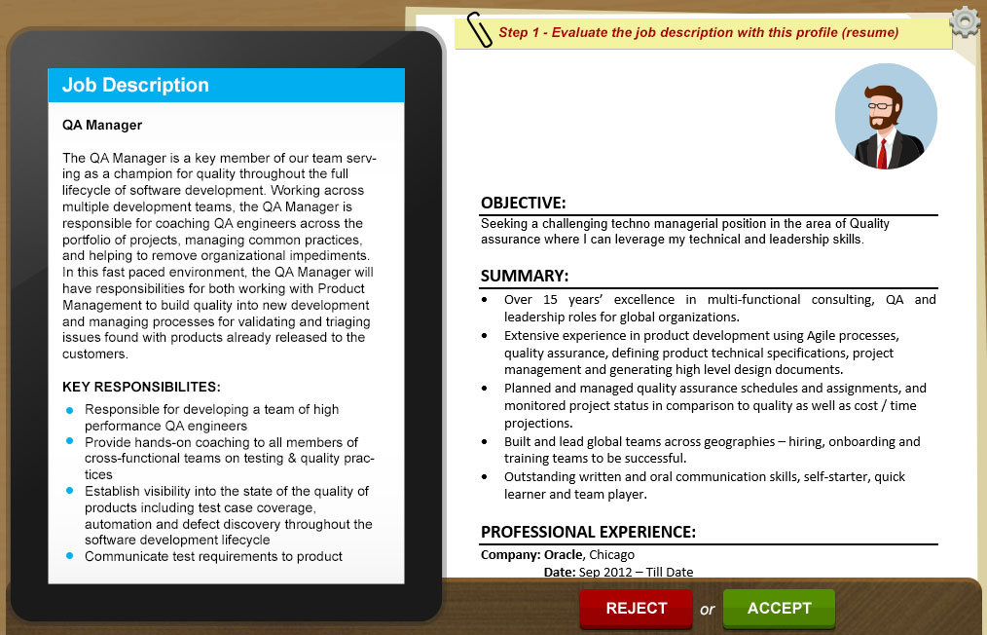

## Step 2: Report Analysis

Review of the Job Description (JD), review of CCAT report and other reports. Here the documents will be shown as small images with labels.

On click of these small document thumbnails, the full documents will open up on the screen, these could run into many pages. The player is expected to read and analyze these before moving forward. We may need to keep the next/continue button disabled till all the documents are opened and read.

Once all the reports are reviewed, the player decides if the candidate under review should be sent forward to the next step by pressing “ACCEPT” or “REJECT” button.

Popup texts: “*Your decision is saved! Click on continue to analyze reports”.* The popup appears with “Continue” button.

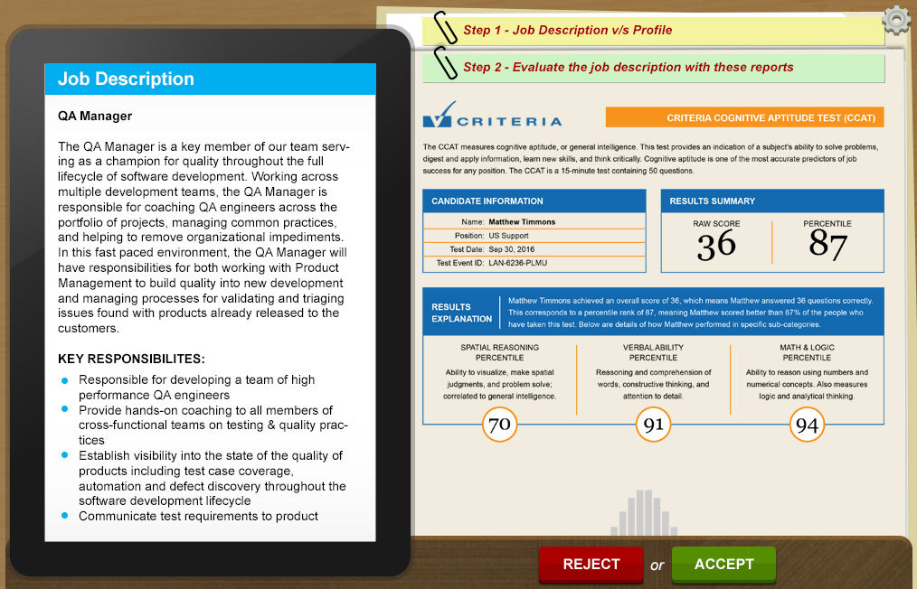

## Step 3: Transcript Analysis

At this stage, players will analyze transcript with the job description. Transcript will be basically communication narrative between the interviewer and the candidate.

On click of these small document thumbnails, the full documents will open up on the screen, these could run into many pages. The player is expected to read and analyze these before moving forward. We may need to keep the next/continue button disabled till all the documents are opened and read.

Once all the pages are reviewed, the player decides if the candidate under review should be sent forward to the next step by pressing “ACCEPT” or “REJECT” button.

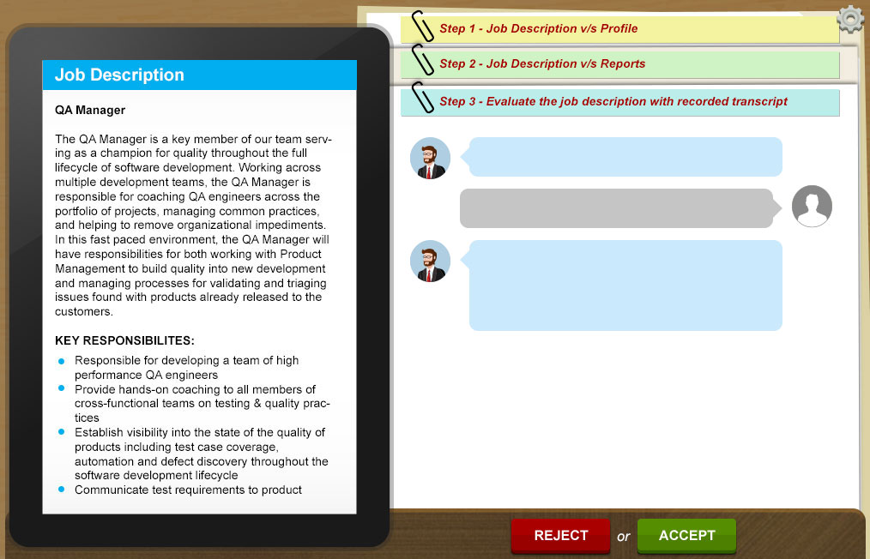

## Step 4(i): Stating reason behind a decision

The player has to justify his/her decision by checking a few check boxes. If the players’ decision is a ‘YES’, then he/she also has to rate the candidate. The players’ choices and rating will be compared with the ‘ideal answers’ set up (at the beak end of the game with a predefined rubric)

There will be 4 reason statements (for acceptance & Rejections). Out of these 4 statements only 2 will be the valid options. Players in this case will be able to select any 2 choices from the given statements.

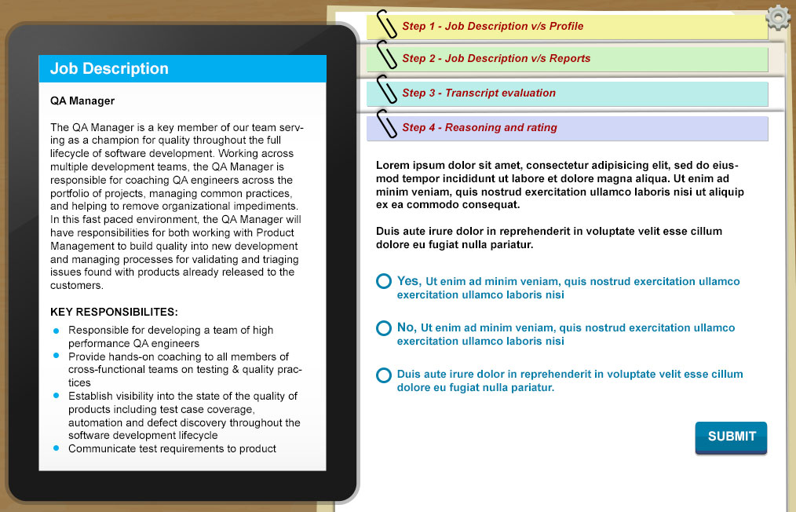

1. Players who have **right decisions in step 1, 2 & 3** will state reasons behind the acceptance. Learners will need to select 2 options from 4 stated acceptance reasons. The AI will evaluate the reason and reward points.
2. Players who have at-least **one wrong decision in step 1, 2 or 3** will now will state reasons behind the Rejection. Learners will need to select 2 options from 4 stated reasons. **In this case players will not earn any points.**
3. Players who **have rejected the invalid case** will state reasons behind the rejection. Learners will need to select 2 options from 4 stated rejection reasons. The AI will evaluate the reason and reward points.

## Step 4(ii): Evaluating the candidature’s rating

Player will need to now evaluate candidate’s rating by rating him from 1 to 10. This will not be part of interaction if player has rejected a case. This will again be matched with calculated rating system.

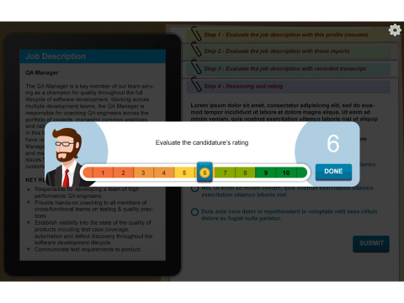

The Hiring Manager will give the player feedback based on the choice made on the previous screen.

# Assumptions:

* Team VCG to provide below supporting inputs.
  + JD’s mapped with associated resumes, reports and transcripts – for 3 cases
  + Ideal path for each of the 3 cases
  + Example of reasoning (accept or reject) statements
  + Ideal rating for profile for each of the 3 cases
  + Game title suggestions